**Justin Thoreson**

**CPSC 3300 Fundamentals of Databases**

**Reflection on Learning**

**04 June 2021**

Description:

During remote learning, students are taking classes at home, and many of them reside in parts of the world that are far away from the institution in which they are enrolled at. This database is meant to illustrate what Seattle U could have potentially decided to do if the online learning persisted for a long time. The database is meant to serve a scheduling service that allows professors to schedule events for their students, and the students can easily convert their classes and other meetings to their time zone. Information regarding professors, students, scheduled events, and the location of the events are stored in the database as well as the connections between them.

Summary of the process:

PDA 2: Creating the ER-Model was somewhat of a long and thought intensive process. It took me some consideration to figure out how I wanted the cardinality and participation constraints to look like. Overall, this was one of the more important steps because it drove the productivity of the rest of the project and certainly made the succeeding steps much easier. The ER-Model mostly fell in line with my initial design in PDA 1, aside from making a small change to the naming conventions of the Creates relationship.

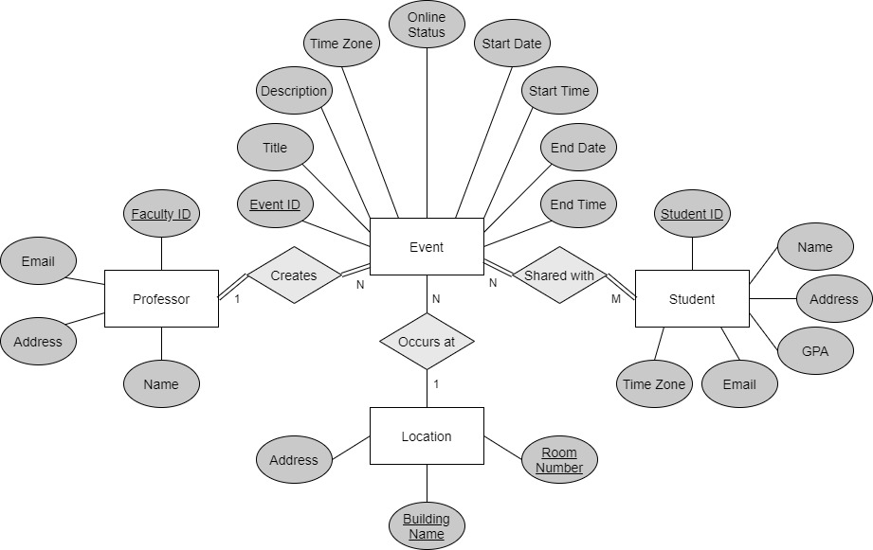

PDA 3:

Relational Model:

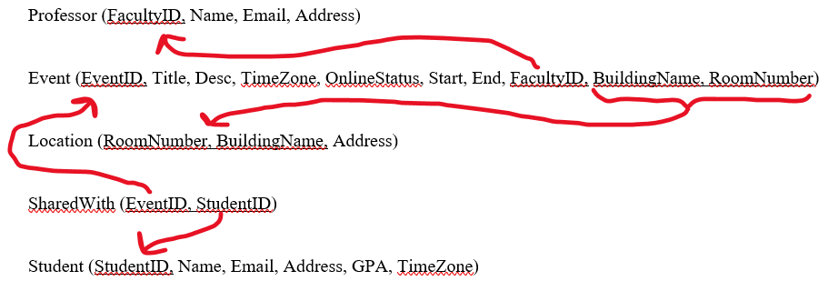

Table creation:

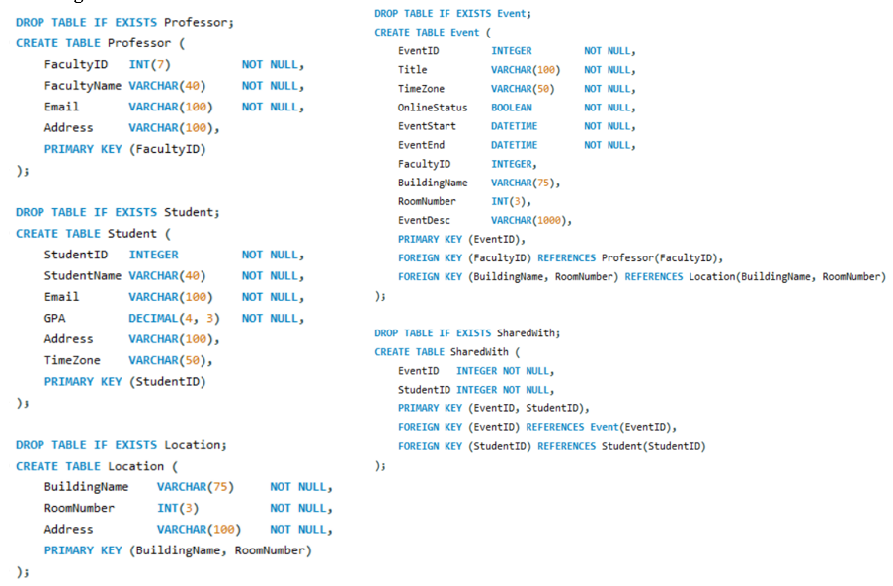

For PDA 2, I had four attributes in the Event table that represented the duration: Start Date, Start Time, End Date, End Time. During PDA 3, I made the decision to change these attributes. Since SQL has a DATETIME data type, I simplified the attributes to EventStart and EventEnd.

PDA 4: Upon importing large amounts of data into the database, I had trouble with making sure the tuples aligned with the database specifications. To solve this, I had to make some changes to the data as well as the database tables. Two of the biggest changes I made were adding ON UPDATE and ON DELETE for the Event and SharedWith tables, and adding a default value to the OnlineStatus attribute of the Event table

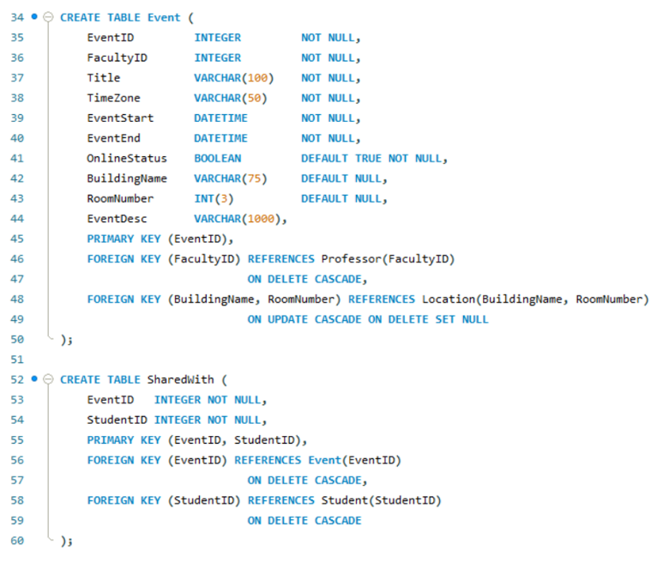

PDA 6: During the DB access application, I did not need to make any changes to the DB or to the data. Getting started on PDA 6 was a little slow, but I managed to get back into the grove of developing simple web pages. Once I developed a page for the select query, I was able to easily translate that work into the other pages. The PHP side was simple as well. All I needed to do for this assignment was concatenate the posts with a conditional statement to determine what kind of query would execute. This part of the assignment was really fun overall and I am glad I was able to implement a web page access to my database. (Pages submitted in PDA 6: Part 1)

Link to main page: [http://css1.seattleu.edu/~thoresonjust/db3300/db_home.html](http://css1.seattleu.edu/~thoresonjust/db3300/db_home.html%20)

Discussion of learning:

Perhaps the greatest challenge of the project was during the early stages of design. At first the ER-modeling was tough because trying to conjure the right entities and formulate the necessary relationships was a new process that took careful thought. Trying to reason through the visual model numerous times was amongst the longest steps of the project. The modeling took careful mental effort and revision. Later in the project, during the database population portion, another issue arose where some of the data I had intended to insert did not follow the rules of my database, and thus would not import correctly. To solve this, I had to take some time reconsidering the data tuples and the database design itself. Eventually, I managed to land on a reasonable design that accepted the necessary tuples.

Aside from the aforementioned challenges, the project persisted rather smoothly. The modeling took lots of effort, and the data population was tedious, but the remainder of the project was completely manageable and even entertaining to work through. The final step, building web pages to access the database, took a lot of time to formulate, but it was not as straining as the modeling portion. I believe this is due to the fact that I have come so far into the project and have learned so much that the SQL came naturally when I needed to implement it into the PHP code. I am happy that I was able to build a functional database on my own for the first time, and I am excited that I had the opportunity to create pages to access it, even if the pages were rather simple and most of the PHP code was already provided. It is a nice feeling to have a lot of fundamental database concepts under my belt after this course. The SQL, the relational database concepts, and the modeling have done wonders in providing me introductory knowledge to databases and database design.